CARE NAVIGATORS
Case study: | Care Navigator Assessment
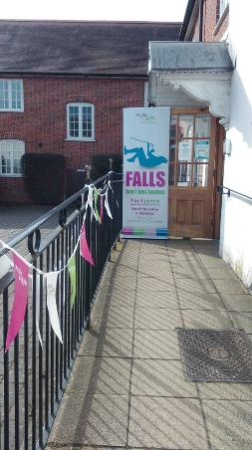

Purpose: | To assess the community support required for a 95 year old lady (Mrs T) whose family were beginning to struggle with her care needs but who wanted to stay independent and safe at home. The initial referral was made by both the Falls Coordinator at a Falls Awareness event and the Health Care Assistant.
How to works: | We discussed how mum struggled with her own personal care now and unable to climb the stairs to the bathroom for a shower or bath. Also how mum wants to have someone come and do her cleaning and washing. They hadn’t considered smoke detectors in the house, as mum sleeps downstairs and son / daughter in law sleep upstairs.  From this we spoke about the handyman service coming and installing another hand rail on the left side of the stairs going up, to help Mrs T up to the bathroom. I discussed with them about contacting social services for a small care package to assist with shower/bath as Mrs T has no savings to pay for this herself. We also spoke about me doing a referral to the fire service for a home safety check, with people sleeping upstairs and down. We discussed using a care agency, private or Age UK for some house work weekly, they had used family in the past and this had not worked out for them.  At the end of the assessment it was greed I would do a Social Service referral for support with personal care, and referral to the fire service for home safety check. They decided to place and advertisement card in the local post office for a cleaner, for a couple of weeks to see if they had any response. If not they wanted to try Age UK. I made a referral to the handyman service for the stair hand rail to add more safety.
Success so far: | It was agreed I would call in a couple of weeks for an update. Mrs T daughter-in-law was so happy because they had social service out to assess Mrs T and suggested 1 day a week respite day care in Blackwater Mill Care Home for bath, and dinner. This has helped the family and Mrs T daughter-in-law said it’s like we have our life back one day a week and we can do normal things, like go out as a couple. Plus Mrs T really like going and has a great time telling the other residents about her travels all over the world.  The fire service came and fitted smoke detectors.  They found a cleaner who lives very close to them and that is working well and helping Mrs T and daughter-in-law.  They cancelled the handyman service as Mrs T would not go up to the bathroom now and they felt the service could be used by someone who was in more need.  Mrs T is now happy and going out more in the week and her son and daughter in law feel the pressure has been removed and feel much happier.
Lessons learnt:
Key contact: | Kim Williams, Age UK Isle of Wight, tel: 01983 525282

